Philip Trinh

SNHU/CS-305

04/02/2023

Module 5 Coding Assignment: Certificate Generation

* Why would you want to use a CA for security?  
  CA is certificate authority that issue secure sockets layer (SSL) certificate. SSL links with public key and are part of a larger network (public key infrastructure PKI). CA acts as digital passport checker who helps secure the internet for everyone. The transport layer security (TLS) protocol uses SSL certificates to encrypt and authenticate data transfer via HTTPS and connect to websites. CA acts as an entity to verify these SSL/TLS certificates for sender and the receiver and help ensure that information is not altered without permission, prevent unauthorize access, and thus protect personal information.
* What are the advantages of using a CA?  
  The advantages to using a Certificate Authority are CA verifies domain names and organizations to validate their identities, then they can show padlock icon on web browser, letting users know that the website is genuine. CA manages list of certificate revocation does not meet policy or expired so user can verify if the source is untrustworthy. Also, CA acts as a third party that provides security for the data going from sender to receiver.
* 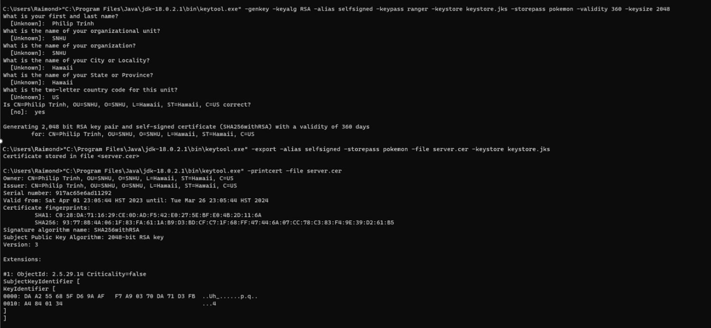**Screenshot of the certificate information form filled out with all fields completed.**
* Text

  Description automatically generated**Screenshot of the printout of the server.cer file**

**Resources**

Awati, R., & Loshin, P. (2021, September 1). Accessed 2023, April 02

*What is a certificate authority (CA)?* SearchSecurity. https://www.techtarget.com/searchsecurity/definition/certificate-authority